**Lab Report**

**Lab – 03**

**Course No: 3110**

**Course Name: Sessional Based on 3109 (Microprocessors and Assembly Language)**

**Submitted To:**

**Sadia Zaman Mishu**

**Assistant Professor,**

**Department of CSE, RUET**

**Submitted By:**

**Anika Tabassum Era**

**Roll: 1703176**

**Section: C**

**Experiment No: 03**

**Experiment Name: Write an assembly language program to find the largest number among 3 decimal numbers which are less than 10.**

**Code:**

**.MODEL SMALL**

**.STACK 100H**

**.DATA**

**MSG1 DB 0AH,0DH, 'Enter three numbers: $'**

**MSG2 DB 0AH,0DH, 'The largest number: $'**

**.CODE**

**MAIN PROC**

**;INITIALIZING PROMPT USER**

**MOV AX, @DATA**

**MOV DS, AX**

**; FIRST PROMPT USER MSG**

**LEA DX, MSG1**

**MOV AH,9**

**INT 21H**

**;INPUT**

**MOV AH, 1**

**INT 21H**

**MOV BL, AL**

**MOV DL, ' '**

**MOV AH, 2**

**INT 21H**

**MOV AH, 1**

**INT 21H**

**MOV BH, AL**

**MOV DL, ' '**

**MOV AH, 2**

**INT 21H**

**MOV AH, 1**

**INT 21H**

**MOV CL, AL**

**CMP BL, BH**

**JGE A**

**B:**

**CMP BH, CL**

**JGE C**

**;LINE FEED**

**MOV DL,0AH**

**MOV AH,2**

**INT 21H**

**;CARRIAGE RETURN**

**MOV DL,0DH**

**MOV AH,2**

**INT 21H**

**;SECOND PROMPT USER MSG**

**LEA DX, MSG2**

**MOV AH,9**

**INT 21H**

**MOV AH, 2**

**MOV DL, CL**

**INT 21H**

**JMP EXIT**

**C:**

**;LINE FEED**

**MOV DL,0AH**

**MOV AH,2**

**INT 21H**

**;CARRIAGE RETURN**

**MOV DL,0DH**

**MOV AH,2**

**INT 21H**

**;SECOND PROMPT USER MSG**

**LEA DX, MSG2**

**MOV AH,9**

**INT 21H**

**MOV AH, 2**

**MOV DL, BH**

**INT 21H**

**JMP EXIT**

**A:**

**CMP BL, CL**

**JGE D**

**;LINE FEED**

**MOV DL,0AH**

**MOV AH,2**

**INT 21H**

**;CARRIAGE RETURN**

**MOV DL,0DH**

**MOV AH,2**

**INT 21H**

**;SECOND PROMPT USER MSG**

**LEA DX, MSG2**

**MOV AH,9**

**INT 21H**

**MOV AH, 2**

**MOV DL, CL**

**INT 21H**

**JMP EXIT**

**D:**

**;LINE FEED**

**MOV DL,0AH**

**MOV AH,2**

**INT 21H**

**;CARRIAGE RETURN**

**MOV DL,0DH**

**MOV AH,2**

**INT 21H**

**;SECOND PROMPT USER MSG**

**LEA DX, MSG2**

**MOV AH,9**

**INT 21H**

**MOV AH, 2**

**MOV DL, BL**

**INT 21H**

**EXIT:**

**MOV AH, 4CH**

**INT 21H**

**MAIN ENDP**

**END** **MAIN**

**Output:**

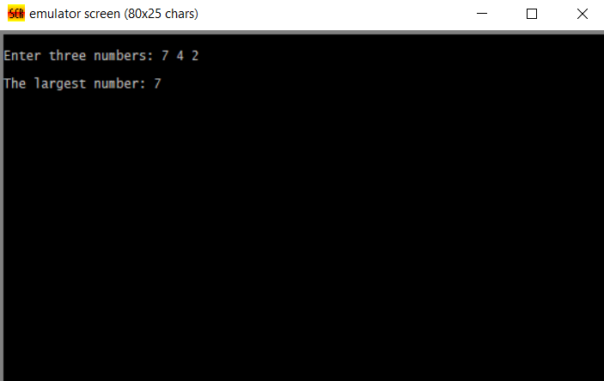

**Discussion: The specified program needs 3 decimal digits to input. And printing extra space while taking the input was implemented. Then the “cmp” and “jge” was used to do the comparison and finally the output was found to be accurate.**